Data Products

Land Surface Climate Data
NEX-Gridded Daily Meteorology (NEX-GDM) land surface climate data are available from 1979 to the current year over the conterminous US. NEX-GDM is a 1-km daily climate data set, including precipitation, minimum temperature, maximum temperature, dew point temperature, wind speed, and solar radiation. These climate data were interpolated between ground weather station measurements from several dozen spatial source datasets. The interpolation algorithm is based on random forest regression, which is extended to estimate the spatial patterns of climate variables. NEX-GDM can be useful for research and practical applications, such as climatology, hydrology, ecology, agriculture, and public health.

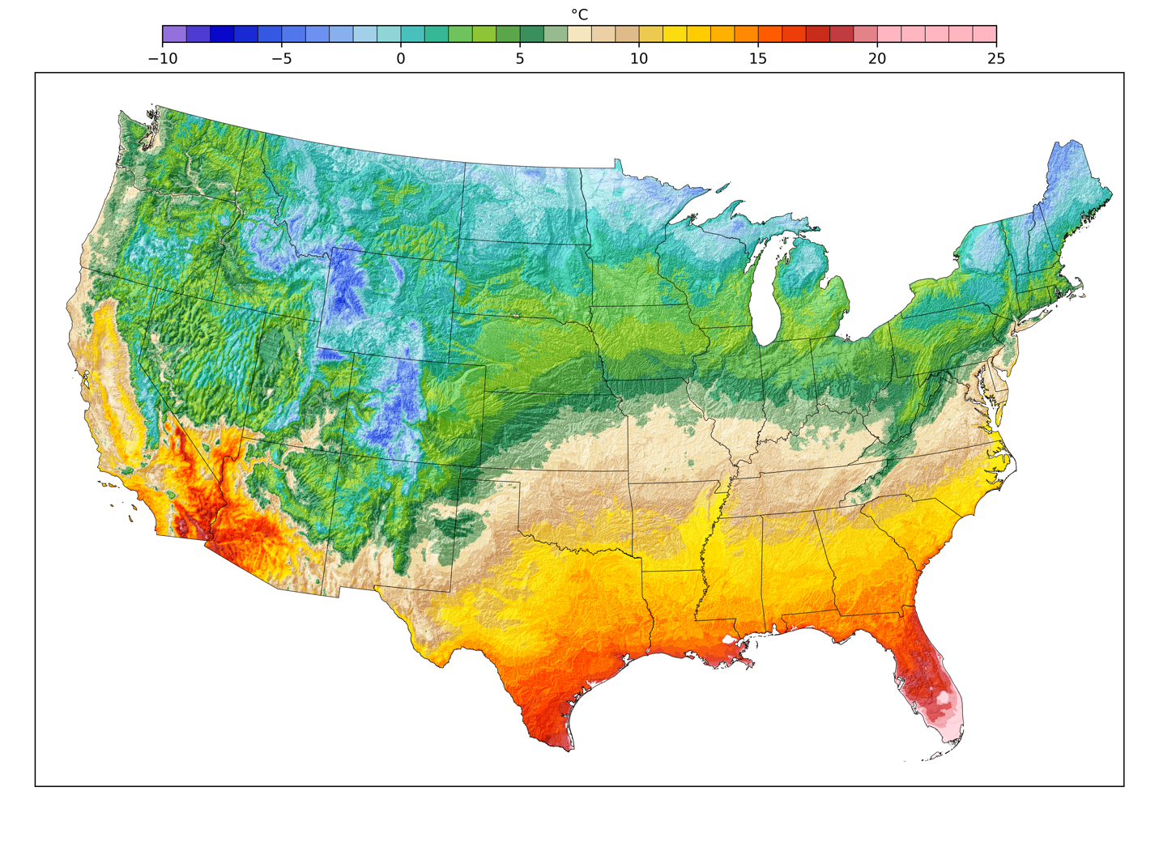
Example: Annual mean of minimum temperature in 2015

Data Access
The NetCDF-4 files of NEX-GDM are available at the NASA HECC data portal, hosted by NASA’s Advanced Supercomputing facility. For questions and/or issues with the data products, email support@nas.nasa.gov and include "GeoNEX" in the subject line. You may wish to register with the GeoNEX mailing list geonex@lists.nasa.gov, see https://lists.nasa.gov/mailman/listinfo/geonex/, where community support and data status announcements will be provided.​
GeoNEX users with NAS accounts can find NEX-GDM on the Lustre file systems here /nex/datapool/geonex/.
Supporting datasets for any research and development of data products, such as MODIS products, Landsat, VIIRS, or any other relevant datasets, can also be found on the NAS file systems at /nex/datapool/ or /nex2/datapool/

File Format
The naming convention of the files is:
NEXGDM_<climate variable>_<YYYY>_<version>.nc
<climate variable>: prcp, tmin, tmax, tdew, wind, and srad for precipitation, minimum temperature, maximum temperature, dew point temperature, wind speed, and solar radiation, respectively
<YYYY>: Year, e.g., 1998
<version>: Product version code. It is currently “100”
The files conform to the CF-1.7 convention and contain detailed information in the attributes.

Projection
NEX-GDM data are in the USGS Albers Equal Area Projection (EPSG:5070). The Proj4 parameter is "+proj=aea +lat_1=29.5 +lat_2=45.5 +lat_0=23 +lon_0=-96 +x_0=0 +y_0=0 +ellps=GRS80 +datum=NAD83 +units=m +no_defs." The upper left corner is -2493045 m in the x-direction and 3310005 m in the y-direction. The grid size is 3150 x 4800.

Data Product Updates and Status
NEX-GDM shall be updated every three to four months. All updates will be announced through the GeoNEX mailing list @ lists.nasa.gov.

Citation
In publications describing analyses based on this dataset, use this citation:
Hashimoto H, Wang W, Melton FS, Moreno AL, Ganguly S, Michaelis AR, and
Nemani RR, High-resolution mapping of daily climate variables by aggregating multiple spatial datasets with the random forest algorithm over the conterminous United States. Int J Climatol. 2019; 39: 2964–2983. https://doi.org/10.1002/joc.5995.

Disclaimer
The data are considered provisional and subject to change. The data are provided as is without any warranty of any kind, either express or implied, arising by law or otherwise, including but not limited to warranties of completeness, non-infringement, accuracy, merchantability, or fitness for a particular purpose. The user assumes all risk associated with the use of, or inability to use, the data.

